About OLAP datagrids
When working with large amounts of data, you can quickly get overwhelmed with the scope and size of the data. For example, you collect sales information for different products, in different regions, and for different customers in a typical two-dimensional spreadsheet. That spreadsheet could easily contain hundreds of rows and tens or even hundreds of columns. Extracting useful information for such a large data collection can be difficult, and trying to identify trends or other patterns in the data can be even harder.
Data visualization is a technique for examining large amounts of data in a compact format. One type of data visualization technique is to use a chart, such as a bar, column, or pie chart. Flex supports many types of charts. For more information, see Introduction to Charts.
Another data visualization technique is to aggregate the data in a compact format, such as in an OLAP (On Line Analytical Processing) datagrid, where an OLAP datagrid is similar to a Pivot Table in Microsoft Excel. An OLAP datagrid displays data aggregations in a two dimensional grid of rows and columns, like a spreadsheet, but the data is condensed based on your aggregation settings.
Note: While the Flex OLAP datagrid is similar to a Pivot Table, it provides a much greater set of features for aggregating data than does a Pivot Table.
For example, you collection sales information on a server in a flat data structure of records, where each record contains information for a single customer transaction, for a single product, in a single quarter. The following code shows the format of this flat data:
data:Object = {
customer:"AAA",
product:"ColdFusion",
year:"2007",
quarter:"Q1"
revenue: "100.00"
}

For a large company with hundreds of customers and tens or hundreds of products, this table could easily contain several thousand rows. Rather than display this information in a standard spreadsheet, you download your data to a Flex application to aggregate sales data by product and quarter, and then display the aggregated data in an OLAP datagrid. From this data aggregation, you can determine trends in sales for each product over time.

About the OLAPDataGrid control
You use the Flex OLAPDataGrid control to display an OLAP datagrid. The following image shows the OLAPDataGrid control displaying the aggregated sales information for product and quarter:
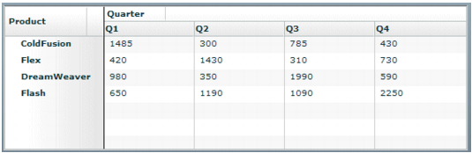
Like all Flex data grid controls, the OLAPDataGrid control is designed to display data in a two-dimensional representation of rows and columns.
You can modify this example to compare quarterly sales from two different years, as the following example shows:
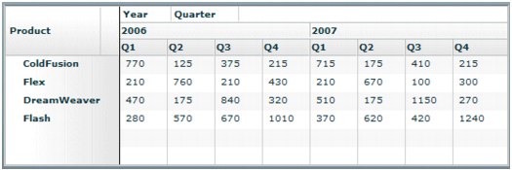
In the previous figure, the columns of the OLAPDataGrid control show a hierarchy of information for year and quarter. You can add multiple level hierarchies for both the columns and the rows of the control.

